

|  |
| --- |
| **FPT UNIVERSITY** |
| Capstone Project Document |

**SMART MEDICINE DICTIONARY**

Report #3 – User Requirement Specification

|  |
| --- |
|  |
| |  |  | | --- | --- | | **Smart Medicine Dictionary** | | | **Group Members** | |  |  | | --- | --- | | Lê Thị Xuân | 01913 | | Phạm Huy Khôi | 01888 | | Phạm Minh Tú | 01770 | | Phạm Hà Hải | 01727 | | Ngô Hà Thu | 01522 | |  |  | | | **Supervisor** | Mr. Nguyễn Văn Sang | | **Project code** | SMD |   - Hanoi, 8/2013- |

**Table of Contents**

**3 USER REQUIREMENT SPECIFICATION** 4

3.1 Introduction 4

1.1.1 Purpose 4

1.1.2 Definition and Acronyms 4

1.2 Overall description 4

3.1.1 Business process overview 4

1.3 Product features 11

1.4 User characteristics 12

1.5 Functional requirement 12

1.5.1 Registration 12

1.5.2 Pharmacy information management 12

1.5.3 Search medicine 12

1.5.4 Search pharmacy 13

1.5.5 Add new medicine 14

1.5.6 Modify medicine information 14

1.5.7 View news 14

1.5.8 News control 14

1.5.9 Medicine Usage Diary 14

1.6 Non – Functional Requirements 14

**2 SYSTEM REQUIREMENT SPECIFICATION 15**

2.1 Introduction 15

2.1.1 Purpose 15

2.1.2 Definition and Acronyms 15

2.1.3 Purpose of that system 15

2.2 System Features 16

2.3 Functional Specification 17

2.3.1 UC001: Search medicine on Mobile 19

2.3.2 UC002: Find the nearest pharmacy on mobile 21

2.3.3 UC003: Medical Usage Diary 23

2.3.4 UC004: Medicine Normal Search 24

2.3.5 UC005: Medicine Advance Search 26

2.3.6 UC006: Pharmacy Normal Search 28

2.3.7 UC007: Pharmacy Advanced Search 30

2.3.8 UC008: Find Nearest Pharmacy (web version) 32

2.3.9 UC009: Register 34

2.3.10 UC010: View News on web 36

2.3.11 Manage News 38

2.3.12 UC016: Login 45

2.3.13 UC017: Log out 49

2.3.14 Manage pharmacy information 51

2.3.15 Manage medicine information 57

2.3.16 Account control 69

2.4 Non-functional Specification 75

2.4.1 User interface 75

2.4.2 Hardware Requirements 76

2.4.3 Software Requirements 76

2.4.4 Reliability 77

2.4.5 Availability 78

2.4.6 Security 78

2.4.7 Maintainability 78

2.4.8 Portability 78

2.4.9 Performance 79

2.5 Entity Relationship Diagram or Data Structures 79

2.5.1 Entity Relationship Diagram 79

2.5.2 Entity Detail 80

# USER REQUIREMENT SPECIFICATION

## Introduction

### Purpose

This document will provide the describing of general requirement and non-functional requirements of our SMD system. After reading, project team and the other people can have an overview about the user requirement specification of the system and also know more about the high level requirements of the system. This document also describes the requirement scope of each phase in the project.

### Definition and Acronyms

|  |  |
| --- | --- |
| Term | Description |
| SMD | Smart Medicine Dictionary |
| GPS | Global Positioning System |
| URL | Uniform Resource Locator |
| LOC | Line of code |

**Table 3-1:** Definition and Acronyms

## Overall description

### Business process overview

SMD is not only an online dictionary about medicine but also a directory to help user find out the nearest pharmacy and the way to get there in need. Therefore, that system will implement the following processes

**NOTE: The meaning of flowchart symbols:**

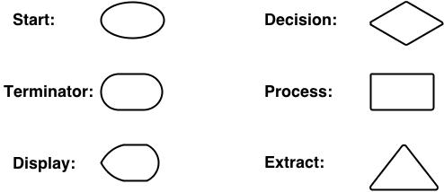

#### Search medicine process workflow

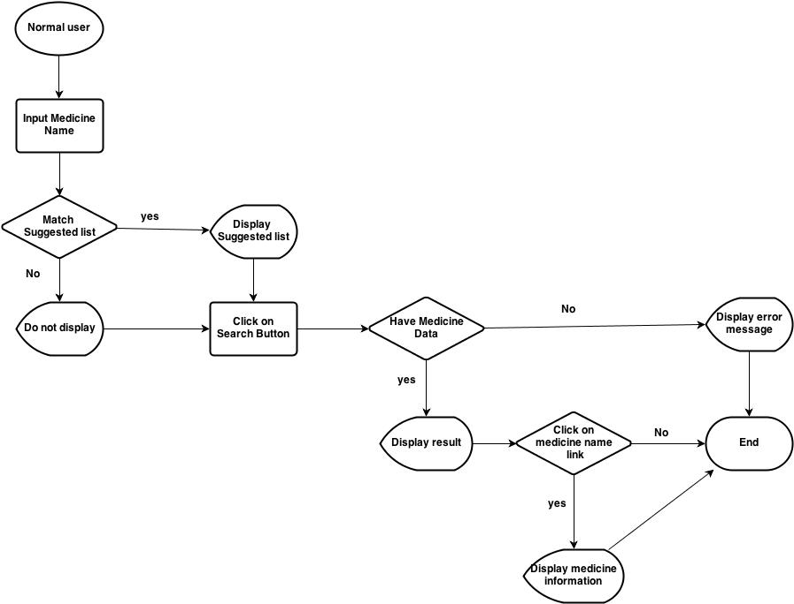

Figure 3-1: Search medicine process workflow

**Brief description**: Everyone can do that search process. It is divided into these steps:

**Step 1**: User inputs medicine name (or information of that medicine) into text box. System has auto-complete feature, therefore, system will list all suggested medicine name that match to what user inserts

**Step 2**: After user click on search button, system will filter from database to find out if that medicine name exist. If it does not exist, system will display error message to inform that data not found. If it exists, system will display result

**Step 3**: User can click on medicine name on table result to see information detail of that medicine

#### Find nearest pharmacy workflow on web module:

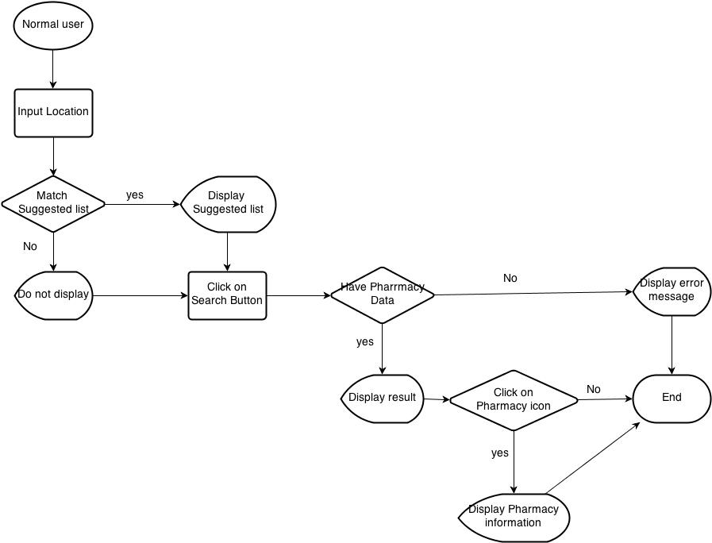

Figure 3-2: Find nearest pharmacy workflow on web module

**Brief description**: Find the nearest pharmacy can also be used by every user.

**Step 1**: User input location name into text box. System has auto-complete feature, therefore, system will list all suggested medicines' name that match to what user input

**Step 2**: After user click on Search button, system will filter to find out which pharmacy has address around that place. If there is no registered pharmacy there, system will display “data not found” message then end process. If system can find pharmacies there, it will display them on google map as location icon

**Step 3**: User can click on one pharmacy icon on Google map to see that pharmacy detail information

#### Find nearest pharmacy workflow on mobile

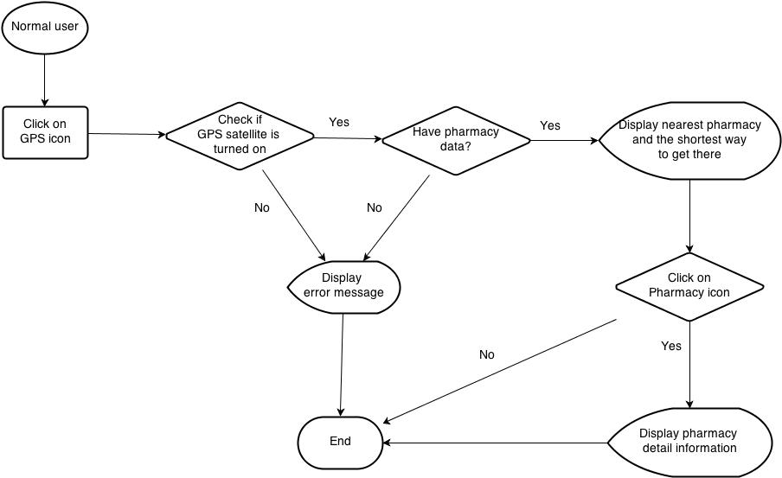

Figure 3-3: Find nearest pharmacy workflow on mobile

**Brief description**: Find the nearest pharmacy can also be used by every user

**Step 1**: To access to that feature on mobile version, after access to that software, user must click on GPS icon. System will access to GPS satellite of their mobile device to find the nearest pharmacy around their location

**Step 2**: System will show the shortest way from their location to the nearest pharmacy. User can click on that pharmacy icon to see that pharmacy detail information

#### Medical Usage Diary workflow

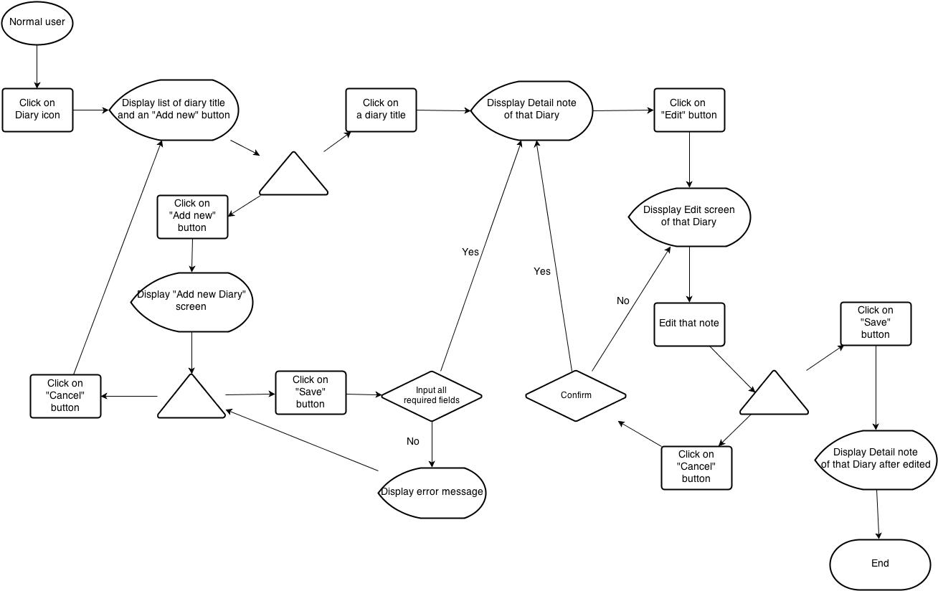

Figure 3-4: Medical Usage Diary workflow

**Brief description**: Medical diary can also be used by every user who use mobile version

**Step 1**: User click on Diary icon after access to that software on their mobile device. System display a list of Diary that has been added and an “Add new” button

**Step 2**: User click on one Diary title on that list. System will display detail note of that Diary with Edit button on the bottom of screen

**Step 3**: After user click on Edit button, system will display Diary Edit screen. User can amend their note then press “Save” button to save edited data. If not, system will return to detail note screen

**Step 4**: User can click on “Add new” button on main Diary screen. System will display Add new diary screen. User can click cancel to back to main Diary screen or fill their note then click “Save” button to save their new note and switch to detail note of that diary

#### Add new and modify workflow

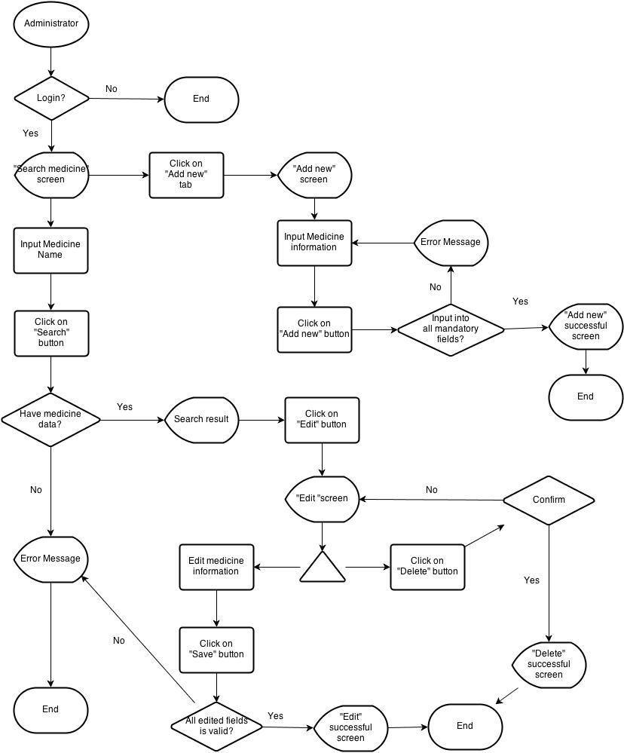

Figure 3-5: Add new and modify workflow

**Brief description**: Only administrator can add new or modify information of medicine and pharmacy.

**Step 1**: System will check if user have logged in as administrator. If the answer is “yes”, system will display “Add new” tab on submenu

**Step 2**: After user click on “Add new” tab, system will display Add new screen

**Step 3**: Administrator must insert all necessary information into all fields then click on “Add new” button. System will check if all fields are validated. Then it will display Successful screen if all fields are valid. If not, return error message

**Step 4**: Administrator click on Search tab on submenu. Insert medicine or pharmacy name then click Search button. System displays result if data can be found

**Step 5**: Administrator click on Edit button beside medicine (pharmacy) name. System display medicine (pharmacy) information

**Step 6**: Administrator amend the information that have to be changed then click “Save” button. System will check the validation of amended information. If it is ok, system will display successful screen

**Step 7**: After accessing into Edit screen, user can also click on “Delete” button on the bottom of that screen to delete that medicine (pharmacy) information

#### Register workflow

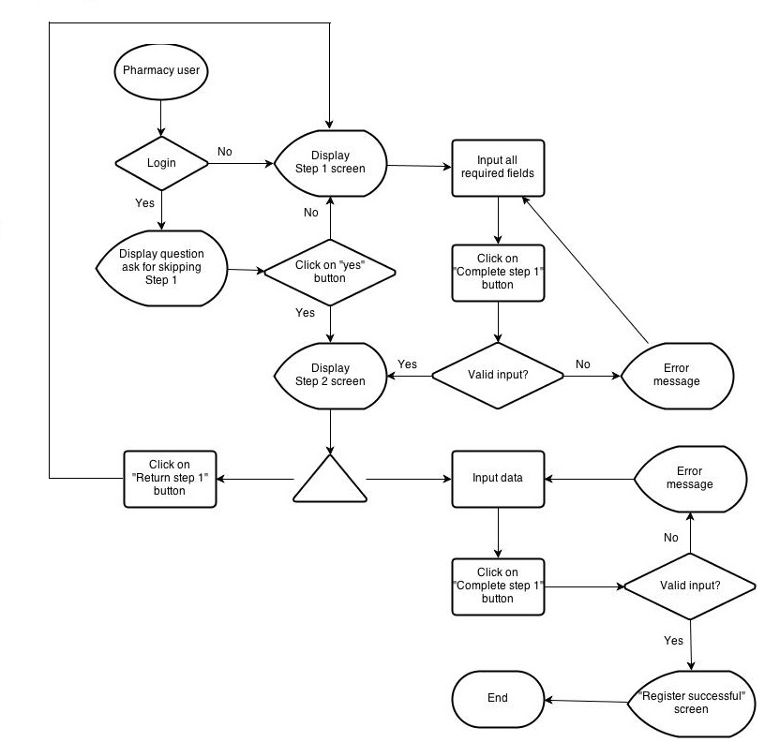

Figure 3-6: Register workflow

**Brief description**:

**Step 1**: System will check if user have logged in system. If user have already logged into that system, system will display question to ask if they continue with their registered information then skip to step 2

**Step 2**: If user choose “yes”, system will skip to step 2 and use their information to auto fill into step 1 screen. If not, continue with step 1 screen

**Step 3**: User insert into all required fields then click on “Complete step 1” button. System will check the validation of all inserted fields. If it is invalid, display error message beside wrong fields. If ok, continue with step 2 screen

**Step 4**: On Step 2 screen, user can choose to return to step 1 to amend information or continue to insert all required data on that screen. After user click on “Complete process” button, system will check the validation of all inserted fields. If it is invalid, display error message beside wrong fields. If ok, system will display success screen

## Product features

SMD is an online system that can run in both web application and Android devices so it is flexible and convenient to use every time and everywhere that can connect to the internet. The system is divided into multiple modules for each specific kind of user. The combination of these modules makes the workflow of the whole system become unified, so that it can work fluently

* **On web module**, that system provides these main functions:
  + **Manage medicine information**

System just allows user who logins as Administrator have permission to manage medicine information. So that they can search/ add new/ edit/ delete/ restore medicine information as they want.

With normal user, they only have permission in add new medicine into the selling list of their pharmacy

* + **Manage pharmacy information**

Administrator user will also have permission to manage pharmacy information. They can accept or reject or delete every pharmacies information which has problem

Normal user can only apply their own pharmacy into system after being accepted by admin

* + **Search medicine**

Everyone who uses that system can make search with medicine information.

* + **Search pharmacy**

Everyone who uses that system can make search with pharmacy information.

* + **Find the nearest pharmacy**

Everyone who uses that system can easily find out the pharmacy that is near by their location by input their position

* + **View news**

Everyone who uses that system can up to date with medical information through that software

* **Mobile module** has these main functions:
  + **Search medicine**

Everyone who uses that system can make search with medicine or pharmacy information.

* + **Find the nearest pharmacy**

Everyone who uses that system can easily find out the pharmacy that is near by their location by accessing their mobile GPS satellite

* + **Diary**

This feature just runs on mobile version. User can save their medicine taking schedule to be alarmed on time

## User characteristics

There are three main actors that system support:

* **Visitor:** Do not have account on system. In general, they should be people who need to search for medicine or pharmacy or they could also people who have few properties and want a fast look up, in short time, a limitation of steps and without registration.
* **Pharmacy User:** Have account on system, they might be pharmacist who has their pharmacy access to our system
* **Administrator:** The full power user of the system who has all functions of normal user and has an Administrator control panel to manage all configuration of system.

## Functional requirement

### Registration

**Access right: Pharmacy user**

That function displays only on web version and it is used only for pharmacist to subscribe website for their pharmacy. They can access registration form from Pharmacy/ Register submenu.

To register, they have to fill all necessary information such as: Pharmacist name, Pharmacy name, Address, Practicing Certificate number, Business License, Phone number…

### Pharmacy information management

**Access right: Administrator**

That function displays only on web version and it is used only for Administrator user. User can only be registered successfully after being accepted by Admin. If Administrator find out a pharmacy that has problem or violate some rule, they can reject or delete it from system

### Search medicine

#### Quick Search

**Access right: Visitor**

The system shall provide facilities on both web and Android smart phone for user to search medicine information by medicine name.

* On web version, this function displays as a bar under sub menu in homepage. User can make a quick search directly from homepage.
* On mobile version, there is only quick search feature. User can access it by tapping on search icon.

#### Advanced Search

**Access right: Visitor**

User can access that function in Medicine/ Advanced Search submenu. This function provides user more option to make search result more precise. It is extremely effective for user who knows exactly what they want to know. They can search by these options:

- Medicine name

- Contraindicated

- Main ingredient

- Manufacture

- Package

### Search pharmacy

#### Quick Search

**Access right: Visitor**

The system shall provide facilities on both web and Android smart phone for user to search pharmacy information by pharmacy name.

- On web module, this function displays as a bar under sub menu in homepage. User can make a quick search directly from homepage.

- On mobile module, there is only quick search feature. User can access it by tapping on search icon.

#### Advanced Search

**Access right: Visitor**

User can access that function in Pharmacy/ Advanced Search submenu. This function provides user more option to make search result more precise. It is extremely effective for user who knows exactly what they want to know. They can search by these options:

- Pharmacy name

- Representative name

- Address

- GPP

### Add new medicine

**Access right: Administrator and Pharmacy user**

That function displays only on web version. Administrator can access that function in Medicine/ Add new on submenu. With register user, they can add new medicine if their selling medicine does not exist in system.

### Modify medicine information

**Access right: Administrator**

That function displays only on web version and it is used only for Admin. They have full permissions on edit/ delete/ restore medicine information as they want.

### View news

**Access right: Visitor**

That feature will collect information from some trustful medical page and update daily to help user be kept up with medical information

### News control

**Access right: Administrator**

The administrator will browse the medical news daily then handling update News part by add, edit, delete news feature of the system

### Medicine Usage Diary

**Access right: Visitor**

This feature just runs on mobile version. User can save their medicine taking schedule on their mobile to be alarmed on time

## Non – Functional Requirements

* Easy to maintain and upgrade
* Ensure data security capabilities, high performance
* GUI is clear, friendly and easy to use.
* System has clear permission for user and can support for user with multi roles.

# SYSTEM REQUIREMENT SPECIFICATION

## Introduction

### Purpose

This document will provide the describing of general requirement and non-functional requirements of our SMD system. After reading, project team and the other people can have an overview about the user requirement specification of the system and also know more about the high level requirements of the system. This document also describes the requirement scope of each phase in the project.

### Definition and Acronyms

|  |  |
| --- | --- |
| Term | Description |
| SMD | Smart Medicine Dictionary |
| GPS | Global Positioning System |
| URL | Uniform Resource Locator |
| LOC | Line of code |

**Table 3-1:** Definition and Acronyms

### Purpose of that system

That system is developed to help two kind of objective users: everyone who cares about medical and pharmacy

* The first purpose of that system is to help users easily find out information about one kind of medicine or pharmacy which they want to know more
* The second purpose is to be a promotion channel for pharmacies. That software can bring pharmacies to be nearer to users

## System Features

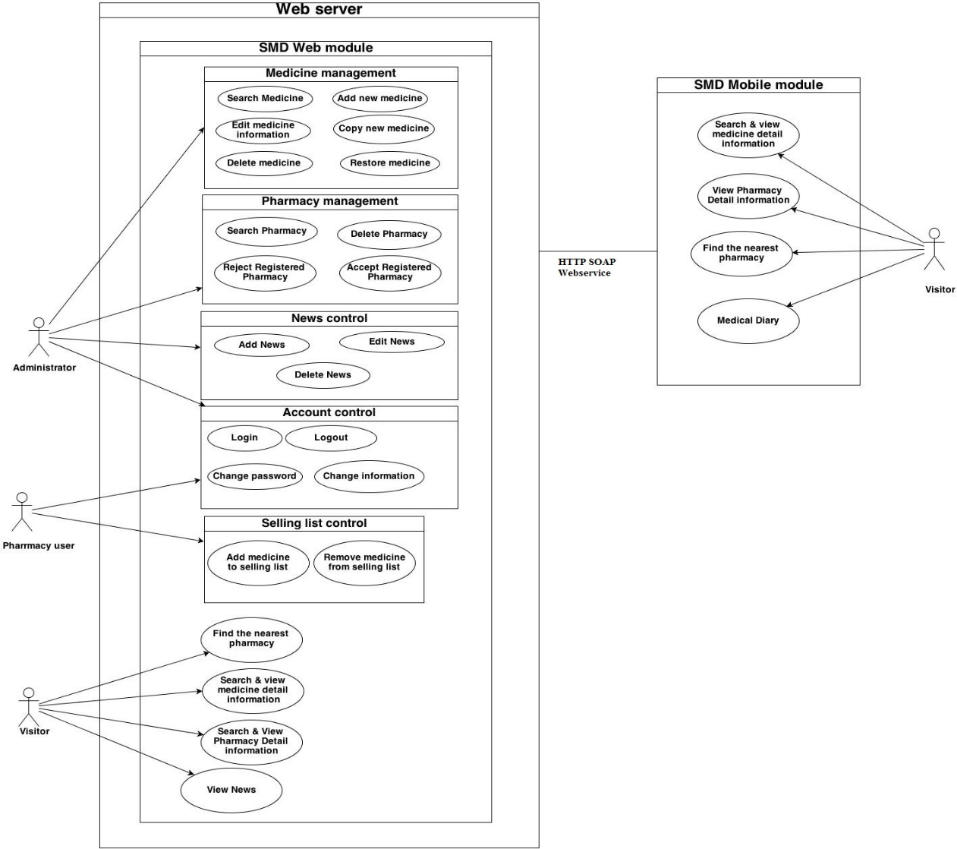

Figure 4-1: System Overview

|  |  |  |  |
| --- | --- | --- | --- |
| **Use Case No.** | **Group of functions** | **Functions** | **Glossary** |
| Mobile module | | |  |
|  | Search Medicine | Normal search | Tìm kiếm thuốc |
| Medicine detail | Thông tin thuốc |
|  | Search Pharmacy | Normal search | Tìm kiếm nhà thuốc |
| Pharmacy detail | Thông tin nhà thuốc |
|  | Medicine selling | Danh sách thuốc |
|  |  | Find the nearest pharmacy | Tìm nhà thuốc gần nhất |
|  |  | Medical Diary | Nhật ký |
| Web module | | |  |
|  | Search medicine | MedicineNormal search | Tìm kiếm thuốc |
|  | Medicine advanced search | Tìm kiếm thuốc nâng cao |
|  | Search pharmacy | Pharmacy Normal search | Tìm kiếm nhà thuốc |
|  | Pharmacy advanced search | Tìm kiếm nhà thuốc nâng cao |
|  | Find the nearest pharmacy | Tìm nhà thuốc gần nhất |
|  | News | View News | Tin tức |
|  | Search News | Tìm kiếm tin tức |
|  | Add News | Thêm mới tin tức |
|  | Edit News | Chỉnh sửa tin tức |
|  | Delete News | Xóa tin tức |
|  | Restore News | Khôi phục |
|  | Account control | Register | Đăng ký |
|  | Login | Đăng nhập |
|  | Logout | Đăng xuất |
|  | <Pharmacy user> Change information | Thay đổi thông tin |
|  | <Pharmacy user> Change password | Thay đổi mật khẩu |
|  | <Pharmacy user> Add new selling medicine | Danh sách thuốc có bán |
|  | Manage pharmacy information | Search registered pharmacy | Tìm kiếm nhà thuốc đã đăng ký |
|  | Accept registered pharmacy | Chấp nhận nhà thuốc đăng ký |
|  | Delete pharmacy | Xóa bỏ nhà thuốc |
|  | Manage medicine information | Search medicine | Tìm kiếm thuốc |
|  | Add new medicine | Thêm mới thuốc |
|  | Copy new medicine | Bản sao thuốc mới |
|  | Edit medicine | Chỉnh sửa thông tin thuốc |
|  | Delete medicine | Xóa bỏ thuốc |
|  | Restore medicine | Khôi phục thuốc |

## Functional Specification

On mobile module, user no need to sign in system, therefore, all features can be used by everyone. However, on web module, use roles are clearly separated for each features as the below table:

|  |  |  |  |  |
| --- | --- | --- | --- | --- |
| **No** | **Use Case** | **Visitor** | **Administrator** | **Pharmacy User** |
|  | Web Module | | | |
|  | Medicine normal search | x | x | x |
|  | Medicine advance search | x | x | x |
|  | Pharmacy normal search |  |  |  |
|  | Pharmacy advance search | x | x | x |
|  | Find the nearest pharmacy | x | x | x |
|  | View News | x | x | x |
|  | Search News |  | x |  |
|  | Add News |  | x |  |
|  | Edit News |  | x |  |
|  | Delete News |  | x |  |
|  | Restore News |  | x |  |
|  | Register |  | x |  |
|  | <Admin> Login |  | x |  |
|  | <Admin> Logout |  | x |  |
|  | <Admin> Search registered pharmacy |  | x |  |
|  | <Admin> Accept registered pharmacy |  | x |  |
|  | <Admin> Delete pharmacy |  | x |  |
|  | <Admin> Search medicine |  | x |  |
|  | <Admin> Add new medicine |  | x |  |
|  | <Admin> Copy new medicine |  | x |  |
|  | <Admin> Edit medicine |  | x |  |
|  | <Admin> Delete medicine |  | x |  |
|  | <Admin> Restore medicine |  | x |  |
|  | <Pharmacy user> Login |  |  | x |
|  | <Pharmacy user> Logout |  |  | x |
|  | <Pharmacy user> Change information |  |  | x |
|  | <Pharmacy user> Change password |  |  | x |
|  | <Pharmacy user> Add new selling medicine |  |  | x |

**Table 2-2:** Table of user’s decent ration

### UC001: Search medicine on Mobile

#### Use Case Diagram

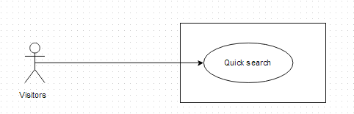

#### Use-Case Specification

|  |  |  |  |  |
| --- | --- | --- | --- | --- |
| **UC001 - Specification** | | | | |
| **Use-case No.** | <UC001> | **Use-case Version** | | <1.0> |
| **Use-case Name** | Search medicine (mobile version) | | | |
| **Author** | Thu NH | | | |
| **Date** | 22/05/2013 | **Priority** | Normal | |
| **Actor:**  Visitor, Pharmacy users, Administrator  **Summary:**  This is one of the main features of that software. On mobile version, user can easily make a quick search to find out information about the medicine they concern by its name everywhere that can connect to the internet  **Preconditions:**  Users have to install that software on their Android devices and it is connecting to the internet  **Post Conditions:**  System displays medicine detail information  **Main Success Scenario:**   |  |  |  | | --- | --- | --- | | **Step** | **User** | **System** | | 1 | Click on that software icon on mobile | Displays home page | | 2 | Click on “Quick Search” tab or Search icon below the screen | Displays search screen including | | 2 | Type medicine name into search box on home page |  | | 3 | Click “Search” button | Display result on the search screen | | 4 | Click on a medicine name | Displays medicine detail information |   **Alternative flows:**   |  |  |  | | --- | --- | --- | | **At Step** | **User** | **System** | | 3 | Click “Search” button | If there is not any medicine matched with the user's input, the system displays an warning message to inform that data not found |     **Business rule**:   * User cannot insert more than 100 characters into medicine name text box * Can only query by medicine name | | | | |

### UC002: Find the nearest pharmacy on mobile

#### Use Case Diagram

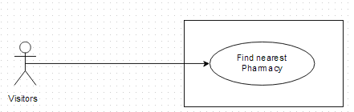

#### Use-case Specification

|  |  |  |  |  |
| --- | --- | --- | --- | --- |
| **UC002 - Specification** | | | | |
| **Use-case No.** | <UC002> | **Use-case Version** | | <1.0> |
| **Use-case Name** | Find nearest pharmacy (mobile version) | | | |
| **Author** | Thu NH | | | |
| **Date** | 22/05/2013 | **Priority** | <High > | |
| **Actor:**  Visitor, Pharmacy users, Administrator  **Summary:**  This is one of the main feature of system. Users only need to insert their location into text box, then press search. All registered pharmacy around their location will display on map with the nearest one is highlighted. Look at the map, users can easily find out the way to get there.  **Triggers**  Users have to install that software in their Android devices and Location Access feature on mobile has been turned on and user clicks on “Find the nearest pharmacy” tab on Home screen  **Preconditions:**  Users have to install that software in their Android devices and Location Access feature on mobile has been turned on  **Post Conditions:**  System displays the nearest pharmacies around user place on map  **Main Success Scenario:**   |  |  |  | | --- | --- | --- | | **Step** | **User** | **System** | | 1 | Click on “Find Nearest Pharmacy” tab on the Home screen | Access their location by GPS satellite of their mobile then display nearest pharmacy around their place on map | | 2 | Click on the nearest pharmacy icon on map | Show that pharmacy information and the direction to get there | | 3 | Typing their location on “Location” text box | Displays nearest pharmacy around the inserted place on map | | 4 | Click on the nearest pharmacy icon on map | Show that pharmacy information and the direction to get there |     **Alternative flows:**   |  |  |  | | --- | --- | --- | | **At Step** | **User** | **System** | | 1 | Click on “Find Nearest Pharmacy” tab | if “Location access” feature is turned off, the system shows Location text box blank. | | 2 | Insert their location on “Location” text box in screen right corner | Displays nearest pharmacy around the inserted place on map |   **Business rule**:   * Cannot input more than 100 characters into Location text box * Just access location in Vietnam | | | | |

### UC003: Medical Usage Diary

#### Use Case Diagram

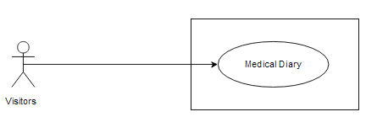

#### Use-case Specification

|  |  |  |  |  |
| --- | --- | --- | --- | --- |
| **UC003 - Specification** | | | | |
| **Use-case No.** | <UC003> | **Use-case Version** | | <1.0> |
| **Use-case Name** | Medical Usage diary | | | |
| **Author** | Thu NH | | | |
| **Date** | 22/05/2013 | **Priority** | <High > | |
| **Actor:**  Visitor, Pharmacy users, Administrator who uses that software on Android devices  **Summary:**  User can use their device as an alarm to take medicine in time or to take note which kinds of medicine they have to use  **Triggers**  Home screen is displayed with available "Medical Diary" tab and user clicks on “Medical Diary” tab on the Home screen  **Preconditions:**  Users have installed that software on their device and Home screen is displayed with available "Medical Diary" tab.  **Post Conditions:**  System must alarm user in time  **Main Success Scenario:**   |  |  |  | | --- | --- | --- | | **Step** | **User** | **System** | | 1 | Click on “Medical Diary” tab on Home screen | Displays Medical diary page with Add new button and list of saved notes | | 2 | Click on Add new button | Displays “New note” screen with these fields:   * “Subject” text box * “Medical list” text box * “Start” text box * “End” text box * “Save” button * “Cancel” button | | 3 | Fill all fields |  | | 4 | Click on “Save” button on "New Note" screen | a. The system validates the input data and then save data into database  b. Displays detail note for each medicine with taking medicine time and dosage then system will automatically alarm user |   **Exceptions:**   |  |  |  | | --- | --- | --- | | **At Step** | **User** | **System** | | 4 | Click on “Cancel” button | These text box will be blank | | | | | |

### UC004: Medicine Normal Search

#### Use Case Diagram



#### Use-case Specification

|  |  |  |  |  |
| --- | --- | --- | --- | --- |
| **UC004 - Specification** | | | | |
| **Use-case No.** | <UC004> | **Use-case Version** | | <1.0> |
| **Use-case Name** | Medicine Normal Search (web version) | | | |
| **Author** | Thu NH | | | |
| **Date** | 22/05/2013 | **Priority** | High | |
| **Actor:**  Visitor, Pharmacy users, Administrator  **Summary:**  This is one of the main features of that software. User can make a quick search to find out information about the medicine they concern by its name right after entering to website  **Goal:**  Search for medicine by its name directly from home page  **Preconditions:**  The Home page (quick search medicine) screen is displayed  **Trigger**:  The Home page is displayed, the medicine name is entered and Search button is clicked.  **Post Conditions:**  System displays medicine detail information  **Main Success Scenario:**   |  |  |  | | --- | --- | --- | | **Step** | **User** | **System** | | 1 | Type medicine name into search box on Home page | Auto-complete feature will check and gives suggested list bases on characters that user input | | 2 | Click “Search” button | Display result- the list of found medicine | | 3 | Click on a medicine name | Displays medicine detail information |   **Alternative Scenarios:**   |  |  |  | | --- | --- | --- | | **At Step** | **User** | **System** | | 3 | Click on other link on screen Search Screen | Switch to selected page |   **Exception:**   |  |  |  | | --- | --- | --- | | **At Step** | **User** | **System** | | 3 | Click “Search” button but medicine does not exist in the database | Return warning message to inform that data not found |     **Business rule:**   * Quick search can only query by medicine name * User cannot input more than 100 characters into text box | | | | |

### UC005: Medicine Advance Search

#### Use Case Diagram

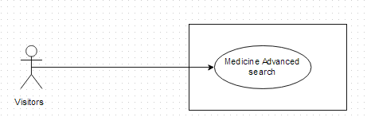

#### Use-case Specification

|  |  |  |  |  |
| --- | --- | --- | --- | --- |
| **UC005 - Specification** | | | | |
| **Use-case No.** | <UC005> | **Use-case Version** | | <1.0> |
| **Use-case Name** | Medicine Advanced Search | | | |
| **Author** | Thu NH | | | |
| **Date** | 22/05/2013 | **Priority** | <High> | |
| **Actor:**  Visitor, Pharmacy users, Administrator  **Summary:**  This is the main function of that system. People have many choices to find out the medicine they concern such as: Medicine name, Contraindicated, Main ingredient, Manufacture, Package  **Goal:**  To search for medicine information  **Triggers**  User click on “Advance search” hyperlink right below “Search” button on Home screen to access “Medicine advanced search” screen. User must input information into the right fields then click “Search” button  **Preconditions:**  The information that user has input must be correctly  **Post Conditions:**  Search medicine must have data information in database  **Main Success Scenario:**   |  |  |  | | --- | --- | --- | | **Step** | **User** | **System** | | 2 | Click on “Medicine/ Medicine Advanced Search” hyperlink on Search Medicine screen | Switch into Advance search page | | 3 | Type the element that they want to filter result by into the right text box |  | | 4 | Click “Search” button | Displays result on the current screen. | | 5 | Click on medicine name on the search result | Displays medicine detail information |   **Alternative Scenario:**   |  |  |  | | --- | --- | --- | | **At** **Step** | **User** | **System** | | 4 | Click another link | Switch to selected page |   **Exceptions:**   |  |  |  | | --- | --- | --- | | **At Step** | **User** | **System** | | 3 | Type the element that they want to filter result by into the right text box (No medicine in database matches these elements) |  | | 4 | Click “Search” button | Return warning message to inform that cannot find matching medicine | | | | | |

### UC006: Pharmacy Normal Search

#### Use Case Diagram

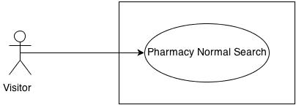

#### Use-case Specification

|  |  |  |  |  |
| --- | --- | --- | --- | --- |
| **UC006 - Specification** | | | | |
| **Use-case No.** | <UC006> | **Use-case Version** | | <1.0> |
| **Use-case Name** | Pharmacy Normal Search | | | |
| **Author** | Thu NH | | | |
| **Date** | 22/05/2013 | **Priority** | <High > | |
| **Actor:**  Visitor, Pharmacy users, Administrator  **Summary:**  With that feature, user can input the element that they have known such as: Brand name, main ingredient, package… into the right element text box on search criteria screen. Basing on what user has input, system will query and find out the appropriate medicine  **Goal:**  Users can find out list of pharmacies that follows their criteria  **Triggers**  User click on “Pharmacy Search” tab on submenu. After input pharmacy name into text box, user must click “Search” button  **Preconditions:**  The information that user has input must be correctly  **Post Conditions:**  System can find out and display detail information of pharmacy which has matched search criteria.  **Main Success Scenario:**   |  |  |  | | --- | --- | --- | | **Step** | **User** | **System** | | 2 | Click on “Pharmacy Search” tab on menu | Displays “Pharmacy Search” with text box to make quick search pharmacy by pharmacy’s name on the current screen. | | 3 | Type pharmacy name into text box then press “Search” button | Displays list of pharmacies that match these criteria | | 4 | Click on pharmacy name | Show that pharmacy information |   **Exceptions:**   |  |  |  | | --- | --- | --- | | **At Step** | **User** | **System** | | 4 | Insert name of an unregistered into text box then press Search button | Return warning message that cannot find data |   **Business rule:** System can only find out pharmacy that has been accepted | | | | |

### UC007: Pharmacy Advanced Search

#### Use Case Diagram

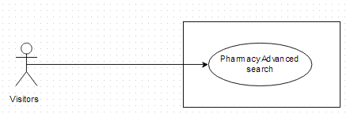

#### Use-case Specification

|  |  |  |  |  |
| --- | --- | --- | --- | --- |
| **UC007 - Specification** | | | | |
| **Use-case No.** | <UC007> | **Use-case Version** | | <1.0> |
| **Use-case Name** | Pharmacy Advanced Search | | | |
| **Author** | Thu NH | | | |
| **Date** | 22/05/2013 | **Priority** | <High > | |
| **Actor:**  Visitor, Pharmacy users, Administrator  **Summary:**  With that feature, user can input the element that they have known such as: Brand name, main ingredient, package… into the right element text box on search criteria screen. Basing on what user has input, system will query and find out the appropriate medicine  **Goal:**  Users can find out list of pharmacies that follows their criteria  **Triggers**  User click on “Pharmacy Search” tab on submenu. Click on “Advanced search” hyperlink below “Search” button. After input information into the right fields, user must click “Search” button  **Preconditions:**  The information that user has input must be correctly  **Post Conditions:**  System can find out and display detail information of pharmacy which has matched search criteria.  **Main Success Scenario:**   |  |  |  | | --- | --- | --- | | **Step** | **User** | **System** | | 1 | Click on “Pharmacy Search” tab on menu | Display “Pharmacy normal search” screen | | 2 | Click on “Pharmacy Advance Search” link beside “Search” button on Search Pharmacy screen | Displays “Search Criteria” screen with these element:   * Pharmacy name * Address * Medicine in store * GPP | | 3 | Insert the criteria they want to filter by into text box then click “Search” button | Displays list of pharmacies that match these criteria | | 4 | Click on pharmacy name | Show that pharmacy information on the Pharmacy Details screen |   **Exceptions:**   |  |  |  | | --- | --- | --- | | **At Step** | **User** | **System** | | 3 | Insert the criteria they want to filter by into text box (No pharmacy match these criteria) then press Search button | Return warning message that cannot find data |   **Business rule:** System can only find out pharmacy that has been accepted | | | | |

### UC008: Find Nearest Pharmacy (web version)

#### Use Case Diagram

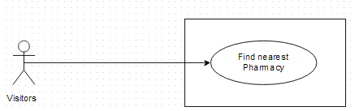

#### Use-case Specification

|  |  |  |  |  |
| --- | --- | --- | --- | --- |
| **UC008 - Specification** | | | | |
| **Use-case No.** | <UC008> | **Use-case Version** | | <1.0> |
| **Use-case Name** | Find Nearest Pharmacy | | | |
| **Author** | Thu NH | | | |
| **Date** | 22/05/2013 | **Priority** | <High > | |
| **Actor:**  Visitor, Pharmacy users, Administrator  **Summary:**  This is one of the main feature of system. Users only need to insert their location into text box, then press search. All registered pharmacy around their location will display on map with the nearest one is highlighted. Look at the map, users can easily find out the way to get there.  **Goal:**  To find the nearest pharmacy around your area or at the location that you want to know  **Triggers**  User click on “Find Nearest Pharmacy” tab on submenu. User must input the right location into “location” text box on “Find nearest pharmacy” screen then click “Search” button  **Preconditions:**  The input location must be in Vietnam  **Post Conditions:**  System still connect to the internet. There must be registered pharmacy at the input location  **Main Success Scenario:**   |  |  |  | | --- | --- | --- | | **Step** | **User** | **System** | | 1 | Click on “Find Nearest Pharmacy” tab | Displays “Find nearest pharmacy” with the text box and search button | | 2 | Insert their location address into text box then press Search button | Displays nearest pharmacy around their place on map | | 3 | Click on the nearest pharmacy icon on map | Show that pharmacy information and the direction to get there |   **Exceptions:**   |  |  |  | | --- | --- | --- | | **At Step** | **User** | **System** | | 3 | Insert location address that do not exist into text box then press Search button | Return error message |   **Business rule:**   * User cannot input more than 250 characters into “Location” text box * Only display accepted pharmacy | | | | |

### UC009: Register

#### Use Case Diagram

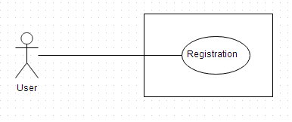

#### Use-case Specification

|  |  |  |  |  |
| --- | --- | --- | --- | --- |
| **UC009 - Specification** | | | | |
| **Use-case No.** | <UC009> | **Use-case Version** | | <1.0> |
| **Use-case Name** | Register | | | |
| **Author** | Thu NH | | | |
| **Date** | 22/05/2013 | **Priority** | <High > | |
| **Actor:**  Pharmacist, who want to use that software for their pharmacies  **Summary:**  Visitor who has pharmacy can create an account to control and public their pharmacy information on that software for another users and visitors know about them. To create account, user must get through 2 steps: insert representative information and insert pharmacy information  **Goal:**  Register an account for representative of a pharmacy  **Triggers**  User click on “Register” tab on submenu. User must have all necessary information of at least one pharmacy to register. After fill all fields of 2 steps, user must click “Complete register” button  **Preconditions:**  All mandatory fields must be filled  **Post Conditions:**  User registers successfully  **Main Success Scenario:**   |  |  |  | | --- | --- | --- | | **Step** | **User** | **System** | | 1 | Click on “Register” tab on submenu | Displays register form | | 2 | Fill all necessary and mandatory information | The system validates the input data | | 3 | Click “Register” button | * The system validates the input data and then save data into database * Go to successful page to inform that user have to confirm it in their email |     **Alternative Scenario:**   |  |  |  | | --- | --- | --- | | **At Step** | **User** | **System** | | 2 | Fill all necessary and mandatory information then click on other feature | Close form and redirect to direct page |   **Exceptions:**   |  |  |  | | --- | --- | --- | | **At Step** | **User** | **System** | | 2 | Insert incorrect information or keep mandatory field blank |  | | 3 | Click “Register” button | Displays Error message beside wrong fields |   **Business rule:**   * User has to input address information as the order: City, District, Street/Village, Number/ Lane * Password must be longer than 8 characters * Mobile number must be longer than 10 numbers | | | | |

### UC010: View News on web

#### Use Case Diagram

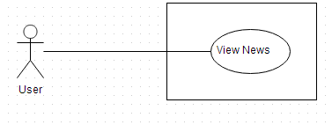

#### Use-case Specification

|  |  |  |  |  |
| --- | --- | --- | --- | --- |
| **UC010 – Specification** | | | | |
| **Use-case No.** | <UC0010> | **Use-case Version** | | <1.0> |
| **Use-case Name** | View news | | | |
| **Author** | Thu NH | | | |
| **Date** | 22/05/2013 | **Priority** | <High > | |
| **Actor:**  Visitor, Pharmacy users, Administrator  **Summary:**  System also supplies medical news to help user be kept up with the newest information about medical. User can view short medical news on News screen of SMD website  **Goal:**  User can up to date medical news directory from that software  **Triggers**  User click on “News” tab on submenu then click on one headline to see the detail of that article  **Preconditions:**  System still connect to the internet  **Post conditions:**  System can display the article in detail  **Main Success Scenario:**   |  |  |  | | --- | --- | --- | | **Step** | **User** | **System** | | 1 | Click on News tab | Displays News screen with some short headline of daily news | | 2 | Clicks on one headline | Shows that article in detail | | | | | |

### Manage News

#### Use Case Diagram

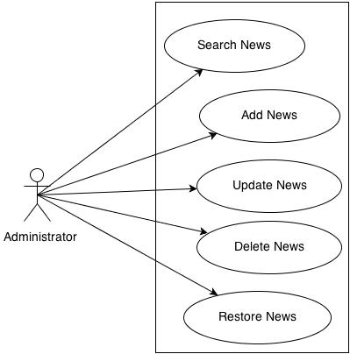

#### Use-case Specification

##### UC0011: Search News

|  |  |  |  |  |
| --- | --- | --- | --- | --- |
| **UC0011 – Specification** | | | | |
| **Use-case No.** | <UC0011> | **Use-case Version** | | <1.0> |
| **Use-case Name** | Search news | | | |
| **Author** | Thu NH | | | |
| **Date** | 22/05/2013 | **Priority** | <High > | |
| **Actor:**  Administrator  **Summary:**  System also supplies medical news to help user be kept up with the newest information about medical. Administrator user can search the list of News to control it  **Goal:**  Administrator can search for the News list  **Triggers**  Administrator click on “Manage News” tab on submenu. User click on “Search News” tab and can input News information into search criteria then click on “Search” button  **Preconditions:**  Input data must be right and it is input into the corrected fields  **Post conditions:**  System can display list of news on search result  **Main Success Scenario:**   |  |  |  | | --- | --- | --- | | **Step** | **User** | **System** | | 1 | Click on “Manage News/ Search News” tab | Displays Search News screen | | 2 | Input data into Search criteria text boxes |  | | 3 | Click on “Search” button | Display the list of corresponding News on search result | | | | | |

##### UC0012: Add News

|  |  |  |  |  |
| --- | --- | --- | --- | --- |
| **UC0012 – Specification** | | | | |
| **Use-case No.** | <UC0012> | **Use-case Version** | | <1.0> |
| **Use-case Name** | Add news | | | |
| **Author** | Thu NH | | | |
| **Date** | 22/05/2013 | **Priority** | <High > | |
| **Actor:**  Administrator  **Summary:**  System also supplies medical news to help user be kept up with the newest information about medical. Administrator user can add medical News into system  **Goal:**  Administrator can add news article to display on News screen successfully  **Triggers**  Administrator click on “Manage News/Add news” tab on submenu. Admin input data into all mandatory field then click “Save” button  **Preconditions:**  Input data must be right and it is input into the corrected fields  **Post conditions:**  System can save new news and display it on News screen  **Main Success Scenario:**   |  |  |  | | --- | --- | --- | | **Step** | **User** | **System** | | 1 | Click on “Manage News/ Add News” tab | Displays “Add News” screen | | 2 | Input data into the correct text boxes |  | | 3 | Click on “Save” button | Save news and display it on News screen | | | | | |

##### UC0013: Update News

|  |  |  |  |  |
| --- | --- | --- | --- | --- |
| **UC0013 – Specification** | | | | |
| **Use-case No.** | <UC0013> | **Use-case Version** | | <1.0> |
| **Use-case Name** | Update News | | | |
| **Author** | Thu NH | | | |
| **Date** | 22/05/2013 | **Priority** | <High > | |
| **Actor:**  Administrator  **Summary:**  System also supplies medical news to help user be kept up with the newest information about medical. To be sure that the information which is provided to customer is the best Administrator user can update medical News if it has some problem  **Goal:**  Administrator can update news article to display on News screen successfully  **Triggers**  Administrator click on “Manage News/Search news” tab on submenu. After find out the news that needs to be edited, admin can click into that article. They can amend data in mandatory field then click “Save” button  **Preconditions:**  Input data must be right and it is input into the corrected fields  **Post conditions:**  System can save updated news and display it on News screen  **Main Success Scenario:**   |  |  |  | | --- | --- | --- | | **Step** | **User** | **System** | | 1 | Click on “Manage News/ Search News” tab | Displays “Search News” screen | | 2 | Search for the news that needs to be edited | Displays list of corresponding news on search result | | 3 | Click into that article | Display “Update News” screen | | 4 | Amend its data in the correct text boxes | Validate the input | | 5 | Click on “Save” button | Save news and display it on News screen | | | | | |

##### UC0014: Delete News

|  |  |  |  |  |
| --- | --- | --- | --- | --- |
| **UC0014 – Specification** | | | | |
| **Use-case No.** | <UC0014> | **Use-case Version** | | <1.0> |
| **Use-case Name** | Delete news | | | |
| **Author** | Thu NH | | | |
| **Date** | 22/05/2013 | **Priority** | <High > | |
| **Actor:**  Administrator  **Summary:**  System also supplies medical news to help user be kept up with the newest information about medical. To be sure that the information which is provided to customer is the best Administrator user can delete medical News if it has some problem  **Goal:**  Administrator can delete news successfully  **Triggers**  Administrator click on “Manage News” tab on submenu. User click on “Search News” tab and can input News information into search criteria then click on “Search” button  **Preconditions:**  Input data must be right and it is input into the corrected fields  **Post conditions:**  System can delete and hide that news on screen  **Main Success Scenario:**   |  |  |  | | --- | --- | --- | | **Step** | **User** | **System** | | 1 | Click on “Manage News/ Search News” tab | Displays “Search News” screen | | 2 | Search for the news that needs to be delete | Displays list of corresponding news on search result | | 3 | Click into that article | Display “Update News” screen | | 4 | Click on “Delete” button | Display popup to ask if user really want to delete that news | | 5 | Click on “Yes” button | Delete news and hide it on News screen |   **Exception:**   |  |  |  | | --- | --- | --- | | **At Step** | **User** | **System** | | 5 | Click on “No” button | Do not delete that news and still display it on News screen | | | | | |

##### UC0015: Restore News

|  |  |  |  |  |
| --- | --- | --- | --- | --- |
| **UC0015 – Specification** | | | | |
| **Use-case No.** | <UC0015> | **Use-case Version** | | <1.0> |
| **Use-case Name** | Restore news | | | |
| **Author** | Thu NH | | | |
| **Date** | 22/05/2013 | **Priority** | <High > | |
| **Actor:**  Administrator  **Summary:**  System also supplies medical news to help user be kept up with the newest information about medical. To be sure that the information which is provided to customer is the best Administrator user can restore medical News  **Goal:**  Administrator can restore news successfully  **Triggers**  Administrator click on “Manage News” tab on submenu. User click on “Search News” tab and can input News information into search criteria, tick on “Deleted” check box then click on “Search” button. Click on “Restore” link beside that news  **Preconditions:**  The news that need to be restored must be deleted before  **Post conditions:**  System can display that news on screen as usual  **Main Success Scenario:**   |  |  |  | | --- | --- | --- | | **Step** | **User** | **System** | | 1 | Click on “Manage News/ Search News” tab | Displays “Search News” screen | | 2 | Tick on “Deleted” check box then search for the news that needs to be restore | Displays list of corresponding news on search result | | 3 | Click on “Restore” link beside the news | Display popup to confirm if user want to restore that news | | 4 | Click on “Yes” button | Restore news and display it on News screen again |   **Exception:**   |  |  |  | | --- | --- | --- | | **At Step** | **User** | **System** | | 4 | Click on “No” button | Do not restore news and still hide it on News screen | | | | | |

### UC016: Login

#### Use Case Diagram

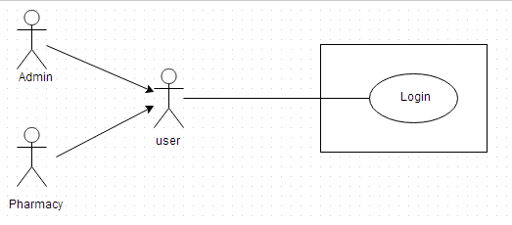

#### Use-case Specification

##### UC016-01: <Admin> Login

|  |  |  |  |  |
| --- | --- | --- | --- | --- |
| **UC016 - Specification** | | | | |
| **Use-case No.** | <UC016> | **Use-case Version** | | <1.0> |
| **Use-case Name** | <Admin> Login | | | |
| **Author** | Thu NH | | | |
| **Date** | 22/05/2013 | **Priority** | <High > | |
| **Actor:**  Administrator  **Summary:**  When Administrator want to do their system controlling work, they must access to system by the username and password that has been set role as admin  **Goal:**  Administrator can log into system successful  **Triggers**  User input username and password correctly in the right text box then click “Login” button  **Preconditions:**  User must have username and password that has been set role as admin to access to system  **Post Conditions:**  User can login successfully as Administrator  **Main Success Scenario:**   |  |  |  | | --- | --- | --- | | **Step** | **User** | **System** | | 1 | Click on “Login” hyperlink on the right top corner | Displays a pop up for Administrator fill their User Name and Password | | 2 | Fill right User Name and Password | The system validates the input data | | 3 | Click “Login” button | Close the pop up and log into system as an Administrator user |     **Alternative Scenario:**   |  |  |  | | --- | --- | --- | | **At** **step** | **User** | **System** | | 3 | Click on Close icon of the pop up | Close the pop up and do not log into system |   **Exceptions:**   |  |  |  | | --- | --- | --- | | **At Step** | **User** | **System** | | 2 | Fill wrong User Name or Password | The system validates the input data | | 3 | Click on “Login” button | Return Error message |   **Business Rule:**   * Username must be input as email full format * Password must be longer than 8 characters | | | | |

##### UC016-02: <Pharmacy user> Login

|  |  |  |  |  |
| --- | --- | --- | --- | --- |
| **UC016-02 - Specification** | | | | |
| **Use-case No.** | <UC0016> | **Use-case Version** | | <1.0> |
| **Use-case Name** | <Pharmacy user> Login | | | |
| **Author** | Thu NH | | | |
| **Date** | 22/05/2013 | **Priority** | <High > | |
| **Actor:**  Pharmacy user  **Summary:**  When pharmacy user wants to log into system to control their data information, they must have username and password that has been set role as pharmacy user to login  **Goal:**  User can log into system successful  **Triggers**  User input username and password correctly in the right text box then click on “Login” button  **Preconditions:**  User must have username and password that has been set role as pharmacy user  **Post Conditions:**  User can login as Pharmacy user and system displays user’s information management screen  **Main Success Scenario:**   |  |  |  | | --- | --- | --- | | **Step** | **User** | **System** | | 1 | Click on “Login” tab | Displays a pop up for user fill their User Name and Password | | 2 | Fill right User Name and Password | The system validates the input data | | 3 | Click “Login” button | Close the pop up and log into system as a Pharmacy user. Display user information management screen |     **Alternative Scenario:**   |  |  |  | | --- | --- | --- | | **At Step** | **User** | **System** | | 3 | Click on Close icon of the pop up | Close the pop up and do not log into system |   **Exceptions:**   |  |  |  | | --- | --- | --- | | **At Step** | **User** | **System** | | 2 | Fill wrong User Name or Password |  | | 3 | Click on “Login” button | Return Error message |   **Business rule:**   * Username must be input as email full format * Password must be longer than 8 characters | | | | |

### UC017: Log out

#### Use Case Diagram

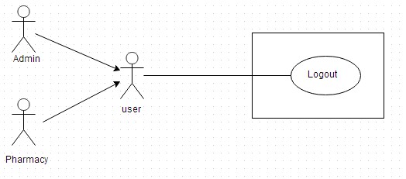

#### Use-case Specification

|  |  |  |  |  |
| --- | --- | --- | --- | --- |
| **UC017 - Specification** | | | | |
| **Use-case No.** | <UC017> | **Use-case Version** | | <1.0> |
| **Use-case Name** | Log out | | | |
| **Author** | Thu NH | | | |
| **Date** | 22/05/2013 | **Priority** | <High > | |
| **Actor:**  Administrator and Pharmacy user  **Summary:**  When users want to finish their system controlling work, they must log out system by click into hyperlink in the right top corner of screen  **Goal:**  Users can log out system successful  **Triggers**  Click on “Log out” hyperlink on right top corner of the page  **Preconditions:**  User has logged in successfully  **Post Conditions:**  Users logout system completely  **Main Success Scenario:**   |  |  |  | | --- | --- | --- | | **Step** | **User** | **System** | | 1 | Have logged into system |  | | 2 | Click on “Log out” link on right top corner of the page | Displays a pop up to confirm if they really want to log out | | 3 | Click “Yes” button | Close the pop up and log out system |   **Alternative Scenario:**   |  |  |  | | --- | --- | --- | | **At Step** | **User** | **System** | | 3 | Click “Close” icon of the pop up | Close the pop up and do not log out system |   **Exceptions:**   |  |  |  | | --- | --- | --- | | **At Step** | **User** | **System** | | 3 | Click “Cancel” button | Close the pop up and do not log out system | | | | | |

### Manage pharmacy information

#### Use Case Diagram

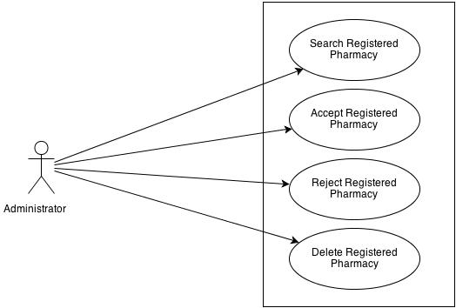

#### Use-case Specification

##### UC0018: <Admin> Search Registered Pharmacy

|  |  |  |  |  |
| --- | --- | --- | --- | --- |
| **UC018 - Specification** | | | | |
| **Use-case No.** | <UC0018> | **Use-case Version** | | <1.0> |
| **Use-case Name** | <Admin> Search registered pharmacy | | | |
| **Author** | Thu NH | | | |
| **Date** | 22/05/2013 | **Priority** | <High > | |
| **Actor:**  Admin  **Summary:**  When Administrator want to look for registered pharmacy information, they have the separate search screen to control pharmacy user data  **Goal:**  Administrator can search pharmacy information successfully if it has been registered  **Triggers**  Click on “Management/ Pharmacy manage” tab, fill pharmacy name into text box then click “Search” button  **Preconditions:**  Input data must be correctly and User has to login as Administrator user  **Post Conditions:**  System must have data of searched pharmacy and can displays detail information of that pharmacy  **Main Success Scenario:**   |  |  |  | | --- | --- | --- | | **Step** | **User** | **System** | | 1 | Have logged into system as an admin |  | | 2 | Click on “Management/ Pharmacy manage” tab | Displays criteria search screen | | 3 | Fill the name of the pharmacy that they want to find into these fields then click “Search” button | Displays search result as a table | | 4 | Click on that pharmacy name | Display “Pharmacy information” screen that contains the information of chosen pharmacy with these elements:   * Pharmacy name * Representative * Phone * Email * Address |   **Alternative Scenario:**   |  |  |  | | --- | --- | --- | | **At Step** | **User** | **System** | | 3 | Fill the name of the pharmacy that they want to find into these fields then click on another link | Switch to selected page |   **Exceptions:**   |  |  |  | | --- | --- | --- | | **At Step** | **User** | **System** | | 3 | Fill the name of the pharmacy that they want to find into these fields (that pharmacy has not registered) then click “Search” button | Return Error message to inform that pharmacy cannot be found | | | | | |

##### UC0019: <Admin> Accept Registered Pharmacy

|  |  |  |  |  |
| --- | --- | --- | --- | --- |
| **UC019 - Specification** | | | | |
| **Use-case No.** | <UC0019> | **Use-case Version** | | <1.0> |
| **Use-case Name** | <Admin> Accept registered pharmacy | | | |
| **Author** | Thu NH | | | |
| **Date** | 22/05/2013 | **Priority** | <High > | |
| **Actor:**  Admin  **Summary:**  When Administrator want to accept for registered pharmacy displays their information on the system  **Goal:**  Pharmacy can register successfully into system  **Triggers**  Click on “Management/ Pharmacy management” tab then search for a pharmacy then tick the check box beside that pharmacy name and click on “Accept” button  **Preconditions:**  Input data must be correctly and User has to login as Administrator user  **Post Conditions:**  Registered pharmacy has been accepted  **Main Success Scenario:**   |  |  |  | | --- | --- | --- | | **Step** | **User** | **System** | | 1 | Have logged into system as an admin |  | | 2 | Click on “Management/ Pharmacy management” tab | Displays criteria search screen | | 3 | Fill the name of the pharmacy that they want to find into these fields then click “Search” button | Displays search result as a table | | 4 | Tick on check box beside the pharmacies that they want to accept |  | | 5 | Click Accept button | Accept these registered pharmacies to have permission to promote their information on that software |     **Alternative Scenario:**   |  |  |  | | --- | --- | --- | | **At Step** | **User** | **System** | | 5 | Click on another link | Switch to selected page. These selected pharmacy has not been accepted |   **Reference:**  UC018 - <Admin> Search Registered Pharmacy | | | | |

##### UC020: <Admin> Delete Registered Pharmacy

|  |  |  |  |  |
| --- | --- | --- | --- | --- |
| **UC020 - Specification** | | | | |
| **Use-case No.** | <UC0020> | **Use-case Version** | | <1.0> |
| **Use-case Name** | <Admin> Delete registered pharmacy | | | |
| **Author** | Thu NH | | | |
| **Date** | 22/05/2013 | **Priority** | <High > | |
| **Actor:**  Admin  **Summary:**  When Administrator want to delete registered pharmacy from the system  **Goal:**  Pharmacy cannot register into system  **Triggers**  Click on “Management/ Pharmacy management” tab then search for a pharmacy then tick the check box beside that pharmacy name and click on “Delete” button  **Preconditions:**  Input data must be correctly and User has to login as Administrator user  **Post Conditions:**  Registered pharmacy has been deleted  **Main Success Scenario:**   |  |  |  | | --- | --- | --- | | **Step** | **User** | **System** | | 1 | Have logged into system as an admin |  | | 2 | Click on “Pharmacy/ Pharmacy management” tab | Displays criteria search screen | | 3 | Fill the name of the pharmacy that they want to find into these fields then click “Search” button | Displays search result as a table | | 4 | Tick on text box beside the pharmacies that they want to delete |  | | 5 | Click Delete button | Delete these pharmacy from system then they do not have permission to promote their information on that software anymore |     **Alternative Scenario:**   |  |  |  | | --- | --- | --- | | **At Step** | **User** | **System** | | 5 | Click on another link | Switch to selected page. These selected pharmacy has not been deleted |   **Reference:**  UC018 - <Admin> Search Registered Pharmacy | | | | |

### Manage medicine information

#### Use Case Diagram

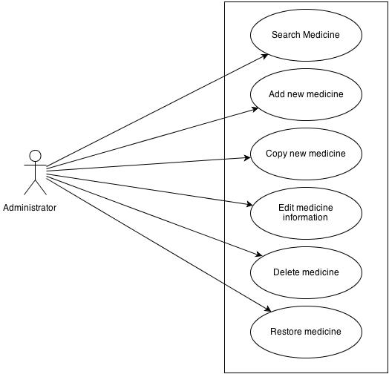

#### User Case Specification

##### UC021: <Admin> Search medicine

|  |  |  |  |  |
| --- | --- | --- | --- | --- |
| **UC021 - Specification** | | | | |
| **Use-case No.** | <UC0021> | **Use-case Version** | | <1.0> |
| **Use-case Name** | <Admin> Search medicine | | | |
| **Author** | Thu NH | | | |
| **Date** | 22/05/2013 | **Priority** | <High > | |
| **Actor:**  Admin  **Summary:**  When Administrator want to search a medicine on database  **Goal:**  Administrator can search medicine information in database successfully if it is existed  **Triggers**  Click on “Management/ Medicine management” tab, input medicine information in the right text box then click “Search” button  **Preconditions:**  Input data must be correctly and User has to login as Administrator user  **Post Conditions:**  Displays medicine detail information  **Main Success Scenario:**   |  |  |  | | --- | --- | --- | | **Step** | **User** | **System** | | 1 | Have logged into system as an admin |  | | 2 | Click on “Medicine/ Medicine Advanced Search ” tab | Displays criteria search screen | | 3 | Fill information of the medicine that they want to find into these fields then click “Search” button | Displays search result as a table | | 4 | Click on that medicine name | Display “Medicine information” screen that contains the information of chosen medicine with these elements:   * Medicine name * Contraindicated * Dosing and Using * Ingredient * Manufacture * Package |     **Alternative Scenario:**   |  |  |  | | --- | --- | --- | | **At Step** | **User** | **System** | | 3 | Fill information of the medicine that they want to find into these fields then click on another link | Switch to selected page |   **Exceptions:**   |  |  |  | | --- | --- | --- | | **At Step** | **User** | **System** | | 3 | Fill information of the medicine that they want to find (that do not exited in database) into these fields then click “Search” button | Return Error message to inform that medicine cannot be found | | | | | |

##### UC022: <Admin> Add New medicine

|  |  |  |  |  |
| --- | --- | --- | --- | --- |
| **UC022 - Specification** | | | | |
| **Use-case No.** | <UC0022> | **Use-case Version** | | <1.0> |
| **Use-case Name** | <Admin> Add new medicine | | | |
| **Author** | Thu NH | | | |
| **Date** | 22/05/2013 | **Priority** | <High > | |
| **Actor:**  Admin  **Summary:**  When Administrator want to add a medicine into database. They have to insert all necessary data of medicine into “Medicine add new” screen  **Goal:**  Administrator can add new medicine information in database successfully  **Triggers**  User must click on “Medicine/ Add new” tab and input all necessary information of medicine into the right fields then click on “Save” button  **Preconditions:**   * User have logged into system as an admin. * All mandatory fields have been filled * All input data must be valid and have not existed in system   **Post Conditions:**  New medicine has been saved into system database successfully  **Main Success Scenario:**   |  |  |  | | --- | --- | --- | | **Step** | **User** | **System** | | 1 | Have logged into system as an admin |  | | 2 | Click on “Medicine/ Add new” tab | Display “Add New” screen that contains these elements:   * Medicine name * Contraindicated * Dosing and Using * Ingredient * Manufacture * Package | | 3 | Fill medicine information into all necessary or mandatory fields |  | | 4 | Click “Save” button | The system validates the input data and then save new medicine data into database |     **Alternative Scenario:**   |  |  |  | | --- | --- | --- | | **At Step** | **User** | **System** | | 4 | Click on another link | Do not save new medicine data into database then redirect to selected page |   **Exceptions:**   |  |  |  | | --- | --- | --- | | **At Step** | **User** | **System** | | 4 | Click “Save” button | Return Error message beside invalid value and do not save data into database | | | | | |

##### UC023: <Admin> Copy New medicine

|  |  |  |  |  |
| --- | --- | --- | --- | --- |
| **UC023 - Specification** | | | | |
| **Use-case No.** | <UC0023> | **Use-case Version** | | <1.0> |
| **Use-case Name** | <Admin> Copy new medicine | | | |
| **Author** | Thu NH | | | |
| **Date** | 22/05/2013 | **Priority** | <High > | |
| **Actor:**  Admin  **Summary:**  When Administrator want to add a medicine on database which has some similar information to an existed medicine  **Goal:**  Administrator can add new medicine information in database successfully  **Triggers**  User must click on “Medicine/ Medicine Advanced Search ” then search for the medicine that they want to copy and amend necessary information of medicine in the right fields then click on “Save” button  **Preconditions:**   * User have logged into system as an admin. * All mandatory fields have been filled * All input data must be valid and have not existed in system   **Post Conditions:**  New medicine has been saved into system database successfully  **Main Success Scenario:**   |  |  |  | | --- | --- | --- | | **Step** | **User** | **System** | | 1 | Have logged into system as an admin |  | | 2 | Click on “Medicine/ Medicine Advanced Search ” then search for the medicine that they want to copy | Displays search result as a table | | 3 | Click on “Copy New” button beside that medicine row | Display “Add New” screen that contains the information of chosen medicine with these elements:   * Medicine name * Contraindicated * Dosing and Using * Ingredient * Manufacture * Package | | 4 | Edit medicine information |  | | 5 | Click “Save” button | The system validates the input data and then save data into database |     **Alternative Scenario:**   |  |  |  | | --- | --- | --- | | **At Step** | **User** | **System** | | 4 | Edit medicine information then click to another link | Do not save edited data then redirect to selected page |   **Exceptions:**   |  |  |  | | --- | --- | --- | | **At Step** | **User** | **System** | | 4 | Edit medicine information to be similar to another existed medicine |  | | 5 | Click “Save” button | The system validates the input data and return Error message and do not save edited data into database |   **Reference:**  UC021 - <Admin> Search Medicine | | | | |

##### UC024: <Admin> Edit medicine

|  |  |  |  |  |
| --- | --- | --- | --- | --- |
| **UC024 - Specification** | | | | |
| **Use-case No.** | <UC0024> | **Use-case Version** | | <1.0> |
| **Use-case Name** | <Admin> Edit medicine | | | |
| **Author** | Thu NH | | | |
| **Date** | 22/05/2013 | **Priority** | <High > | |
| **Actor:**  Admin  **Summary:**  When Administrator want to edit a medicine on database  **Goal:**  Administrator can change that medicine information in database successfully  **Triggers**  User must click on “Medicine/ Medicine Advanced Search ” then search for the medicine that they want to edit and amend necessary information of medicine in the right fields then click on “Save” button  **Preconditions:**   * User have logged into system as an admin. * All mandatory fields have been filled * All input data must be valid and have existed in system   **Post Conditions:**  Changed information of medicine has been saved into system database successfully  **Main Success Scenario:**   |  |  |  | | --- | --- | --- | | **Step** | **User** | **System** | | 1 | Have logged into system as an admin |  | | 2 | Click on “Medicine/ Medicine Advanced Search ” then search for the medicine that they want to edit | Displays search result as a table | | 3 | Click on Edit button beside that medicine row | Display “Medicine information” screen that contains the information of that medicine with these elements:   * Medicine name * Contraindicated * Dosing and Using * Ingredient * Manufacture * Package | | 4 | Edit medicine information |  | | 5 | Click “Save” button | The system validates the input data and then save edited data into database |     **Alternative Scenario:**   |  |  |  | | --- | --- | --- | | **At Step** | **User** | **System** | | 4 | Edit medicine information then click to another link | Do not save edited data then redirect to selected page |   **Exceptions:**   |  |  |  | | --- | --- | --- | | **At Step** | **User** | **System** | | 4 | Edit medicine information to be similar to another existed medicine |  | | 5 | Click “Save” button | The system validates the input data and then return Error message and do not save edited data into database |   **Reference:**  UC0021 - <Admin> Search Medicine | | | | |

##### UC025: <Admin> Delete medicine

|  |  |  |  |  |
| --- | --- | --- | --- | --- |
| **UC025 - Specification** | | | | |
| **Use-case No.** | <UC0025> | **Use-case Version** | | <1.0> |
| **Use-case Name** | <Admin> Delete medicine | | | |
| **Author** | Thu NH | | | |
| **Date** | 22/05/2013 | **Priority** | <High > | |
| **Actor:**  Admin  **Summary:**  When Administrator want to delete a medicine on database  **Goal:**  Administrator can change that medicine’s delete flag to “1”in database successfully  **Triggers**  User must click on “Medicine/ Medicine Advanced Search ” then search for the medicine that they want to delete and tick on check box beside medicine name then click on “Delete” button  **Preconditions:**   * User have logged into system as an admin. * All mandatory fields have been filled * All input data must be valid and have existed in system   **Post Conditions:**  Medicine has been deleted from system database successfully  **Main Success Scenario:**   |  |  |  | | --- | --- | --- | | **Step** | **User** | **System** | | 1 | Have logged into system as an admin |  | | 2 | Click on “Medicine/ Medicine Advanced Search ” then search for the medicine that they want to edit | Displays search result as a table | | 3 | Click on “Delete” button beside that medicine row | Displays pop up to confirm if they really want to remove that medicine | | 4 | Click “Yes” button on popup | Closes the popup then remove that medicine name from medicine list |     **Alternative Scenario:**   |  |  |  | | --- | --- | --- | | **At Step** | **User** | **System** | | 4 | Click close icon of the popup | Only closes the popup, does not remove that medicine |   **Exceptions:**   |  |  |  | | --- | --- | --- | | **At Step** | **User** | **System** | | 4 | Click “Cancel” button on popup | Only closes the popup, does not remove that medicine |   **Reference:**  UC021 - <Admin> Search Medicine | | | | |

##### UC026: <Admin> Restore medicine

|  |  |  |  |  |
| --- | --- | --- | --- | --- |
| **UC026 - Specification** | | | | |
| **Use-case No.** | <UC0026> | **Use-case Version** | | <1.0> |
| **Use-case Name** | <Admin> Restore medicine | | | |
| **Author** | Thu NH | | | |
| **Date** | 22/05/2013 | **Priority** | <High > | |
| **Actor:**  Admin  **Summary:**  When Administrator want to restore a deleted medicine on database  **Goal:**  Administrator can change that medicine’s delete flag to “0”in database successfully  **Triggers**  User must click on “Medicine/ Medicine Advanced Search”. Tick on “Deleted” check box then search for the medicine that they want to restore and tick on check box beside medicine name then click on “Restore” button  **Preconditions:**   * User have logged into system as an admin. * All mandatory fields have been filled * All input data must be valid and have been deleted from system   **Post Conditions:**  Deleted medicine has been restored in system database successfully  **Main Success Scenario:**   |  |  |  | | --- | --- | --- | | **Step** | **User** | **System** | | 1 | Have logged into system as an admin |  | | 2 | Click on “Medicine/ Medicine Advanced Search ” tab | Displays “Medicine Advanced Search” page | | 3 | Tick on Delete flag then search for the medicine that they want to edit | Displays search result as a table | | 3 | Click on “Restore” button beside that medicine row | Displays pop up to confirm if they really want to restore that medicine | | 4 | Click “Yes” button on popup | Closes the popup then restore that medicine name in medicine list |     **Alternative Scenario:**   |  |  |  | | --- | --- | --- | | **At Step** | **User** | **System** | | 4 | Click close icon of the popup | Only closes the popup, does not remove that medicine |   **Exceptions:**   |  |  |  | | --- | --- | --- | | **At Step** | **User** | **System** | | 4 | Click “Cancel” button on popup | Only closes the popup, does not remove that medicine |   **Business Rule:**  Medicine can only be restored if there is no similarly medicine existed  **Reference:**  UC0025 - <Admin> Delete medicine | | | | |

### Account control

#### Use Case Diagram

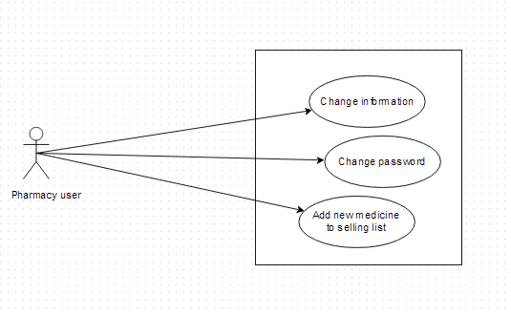

#### Use-case Specification

##### UC027: <Pharmacy user> Change Information

|  |  |  |  |  |
| --- | --- | --- | --- | --- |
| **UC027 - Specification** | | | | |
| **Use-case No.** | <UC0027> | **Use-case Version** | | <1.0> |
| **Use-case Name** | <Pharmacy user> Change information | | | |
| **Author** | Thu NH | | | |
| **Date** | 22/05/2013 | **Priority** | <High > | |
| **Actor:**  Pharmacy user  **Summary:**  When user want to change their registered information  **Goal:**  User can change the information that have permission to change  **Triggers**  Click on User name link on right top corner of page. System displays User information screen. Click on “Change information” button then amend information. Click “Save” button  **Preconditions:**  All mandatory fields must be filled and User have logged into system as a pharmacy user  **Post Conditions:**  The new information has been saved successfully  **Main Success Scenario:**   |  |  |  | | --- | --- | --- | | **Step** | **User** | **System** | | 1 | Have logged into system as an user |  | | 2 | Click on User name link on right top corner of page | Displays User information screen | | 3 | Click on “Change information” button | Display Change information screen | | 4 | Type new information into text fields (validate) |  | | 5 | Click on “Save” button | The system validates the input data and then save new information into database |   **Exceptions:**   |  |  |  | | --- | --- | --- | | **At Step** | **User** | **System** | | 4 | Type new information into text fields (invalidate) |  | | 5 | Click on “Save” button | The system validates the input data and then displays error message beside wrong fields | | | | | |

##### UC028: <Pharmacy user> Change password

|  |  |  |  |  |
| --- | --- | --- | --- | --- |
| **UC028 - Specification** | | | | |
| **Use-case No.** | <UC0028> | **Use-case Version** | | <1.0> |
| **Use-case Name** | <Pharmacy user> Change password | | | |
| **Author** | Thu NH | | | |
| **Date** | 22/05/2013 | **Priority** | <High > | |
| **Actor:**  Pharmacy user  **Summary:**  When user want to change their register password or when they forgot their password, they can offer to a new one right after access to login feature  **Goal:**  User can change their password successfully  **Triggers**  1. User has accessed to SMD website. Click on “Login” tab then click on “Do not remember password”. Insert their registered email then click “Send” button  2. User login to system then click on “Change password” link on the right top corner of the page. Insert current password then insert new password that is validate then click “Save” button  **Preconditions:**   * Users have to remember their registered email * If user change password after login, new password must be valid   **Post Conditions:**  Password has been changed successfully  **Main Success Scenario:**   |  |  |  | | --- | --- | --- | | **Step** | **User** | **System** | | 1 | Have logged into system as an user |  | | 2 | Click on “Change password” link on the right top corner of the page | Switches to “Change password” page | | 3 | Insert current password then insert new password that is validate | The system validates the input data | | 4 | Click “Finish” button | Display successful page with message to inform user that new password can be used after being confirm by admin |     **Alternative Scenario:**   |  |  |  | | --- | --- | --- | | **At Step** | **User** | **System** | | 1 | Click on “Login” hyperlink on the right top corner |  | | 2 | Click on “Forget password” link | Switches to “Change password” page | | 3 | Insert their registered email then click “Send” button | The system validates the input data and sends new password to that email | | 4 | Use that new email to login system | Login successfully |     **Exceptions:**   |  |  |  | | --- | --- | --- | | **At Step** | **User** | **System** | | 1 | Have logged into system as an user |  | | 2 | Click on “Change password” link on the right top corner of the page | Switches to “Change password” page | | 3 | Insert current password then insert new password that is invalid | The system validates the input data and then displays error message beside wrong value | | 4 | Click “Finish” button | Displays successful page with message to inform user that new password can be used after being confirm by admin | | | | | |

##### UC029: <Pharmacy user> Add new medicine into pharmacy’s sell list

|  |  |  |  |  |
| --- | --- | --- | --- | --- |
| **UC0029 - Specification** | | | | |
| **Use-case No.** | <UC0029> | **Use-case Version** | | <1.0> |
| **Use-case Name** | <Pharmacy user> Add new medicine into pharmacy’s selling list | | | |
| **Author** | Thu NH | | | |
| **Date** | 22/05/2013 | **Priority** | <High > | |
| **Actor:**  Pharmacy user  **Summary:**  When user want to add a new medicine into their selling list, they can control their selling list right in their manage information tab  **Goal:**  User can add medicine information into database  **Triggers**  After login system, user click on “Manage” tab on submenu then click on “Selling list” tab and click on “Add new” button. User search for a medicine then tick on check box beside it and click on “Add” button  **Preconditions:**   * Medicine in selling list must have data information in SMD system * User have logged into system as a pharmacy user   **Post Conditions:**  Medicine can be added into pharmacy selling list successfully  **Main Success Scenario:**   |  |  |  | | --- | --- | --- | | **Step** | **User** | **System** | | 1 | Have logged into system as a pharmacy user |  | | 2 | Click on Manage tab on submenu | Display Manage screen with representative information and pharmacy list of that user | | 3 | Click on one pharmacy name | Display screen with 2 tabs: Pharmacy information and “Selling list” | | 4 | Click on “Selling list” tab | Display screen that is similar to advanced search screen to look for list of medicine which are selling in that pharmacy. On the bottom of screen, there is “add new” button | | 5 | Click on “Add new” button | Display new screen with 2 tabs: Search medicine, add new | | 6 | Click on Search medicine | Display tab content that has similar format to Quick search screen to look for the existed medicine on system | | 7 | Search for the medicine that need to be added. Tick on the check box beside it then click on “Add” button | Add that medicine name into Selling list of that pharmacy |     **Alternative Scenario:**   |  |  |  | | --- | --- | --- | | **At Step** | **User** | **System** | | 6 | Click on “Add new” tab | Display Add new screen that has similar format to admin’s screen | | 7 | Fill all necessary information then click “Save” button | The system validates the input data and then save that medicine information into database and add its name into Selling list of that pharmacy |   **Exception**:   |  |  |  | | --- | --- | --- | | **At Step** | **User** | **System** | | 6 | Click on “Search medicine” tab | Display the screen that have similar format to Quick search screen | | 7 | Search for the medicine that need to be added (That medicine name does not exist in database) | Return warning message that data not found and display “Add brand new” button |   **Reference:**  UC005 - Quick search  UC016 - <Admin> Add new medicine | | | | |

## Non-functional Specification

### User interface

**a. Arrangement**

SDM will have 4 areas: Banner, Submenu, Content, Contact and information

* The banner will display on the top of the page and contain: SDM icon and name of the program
* Elements in Submenu will change as role of user
* Content displays below submenu and change interface as feature users have chosen
* Contact and information will display on the bottom of page and contain necessary information to help user to contact administrators in need

**b. Color**

The system has been designed to use less and simple color to make the page be fresh and clearly to user. Users can easily notice what they want

**c. Text**

All text bases on Tahoma style. Their size and font style will rely on their type, their function. The text style will be divided into some specific types to make the website be unified

### Hardware Requirements

All data and applications installed at the servers, so it should be required the best equipment. When equipped servers, it is necessary to pay attention to the following element:

* **Configuration suggestions:**

|  |  |  |  |
| --- | --- | --- | --- |
| **#** | **Name** | **Configuration** | **Description** |
| **1** | **Application Server** | RAM: 2GB  Hard disk: 150GB  Chipset: Core 2 Dual 2.0 GHz | Server for application server to deploy web application with the minimum configuration |
| **2** | **Client** | RAM:2GB Hard disk: 150GB Chipset: Core 2 Dual 2.0 GHz | Notebooks for developing/testing with the minimum configuration |
| **3** | **Mobile device** | RAM: 1 GB  Hard disk: 32GB  Chip 1.5GHz Core 4-PLUS-1 Quad | Mobile installed application with configuration |

* **Configured transmission line:** Depending on the actual topography of each deployment environment that function setting up the network will be able to use copper cable, optical cable or wireless.

### Software Requirements

|  |  |  |
| --- | --- | --- |
| **Software name** | **Version** | **Source** |
| Firefox | 20 | Mozilla |
| Chrome | 25 | Google |
| Android | Upper from 2.3 | Google |
| Operating System: Microsoft® Windows 7 | 2007 | Microsoft |
| .Net Framework | 4.0 | Microsoft( used to setup MySQL) |
| DBMS: MySQL Workbench | 5.6.11.0 | Oracle |
| IDE: Eclipse Indigo | indigo-SR1-win32 | Eclipse |
| Strut | 2 | Apache |
| Spring | 3 | Spring |
| Hibernate | 3 | Hibernate |

**Table 4-1:** Software requirement

### Reliability

* The database must be backed up daily and can be recovered if necessary
* Mean time between failures (MTBF): The mean time between each failure is expected to be about 480 hours (20 days) of using.
* Mean time to repair (MTTR): Immediately when Administrator finds out problem or website is attacked by someone. Average 1 day.
* The maximum bugs per function are 2 bugs/a function when user uses software within 2 months. The average number of bugs in the software during system testing is about to be around 0.5 bugs/1000LOC.

| **Bug** | **Definition** |
| --- | --- |
| Minor | Bugs related to GUI |
| Significant | Bugs related to minor business logic |
| Critical | Function can’t execute correctly, completely loss of data, disconnect to the server |

**Table 4.1 –** Bugs or Defect Rate

### Availability

The available time is approximately 99% and must be available 24 hours a day, 7 days a week, besides user must have the ability to access website by any web browser in his or her computers or mobile devices.

### Security

In order to avoid unwanted access by strangers, the security implemented in various ways:

* **User layer:** Each pharmacy representative must be distributed system access and manipulate the individual parts. To edit information, user must declare their usename and password before the operation. Functions will be shown after users login dependencies user’s role and permission of each user.
* **Manage Data Layer:** Only Administrator can modify database system.
* **Stored Data:** All data about information of user, medicine, pharmacy, and news will be saved in My SQL Server, and be easy for data classification or backup.

### Maintainability

* **Coding standards and naming conventions**
  + Output of the project must include coding standards and naming conventions documentations. Implementation code must be easy to maintain.
  + All code must be clearly commented, including class, method documentations.
  + If some components are reused, the documentations of those components must also be included.
* **Design**
  + The design of the system must be loosely coupled that chances on some module will not affect others.
* **Logging**
  + All the errors should be logged, supporting for bug fixing and maintenance.
  + All strange or sensitive situations should also be logged.

### Portability

* Website can be deployed on Windows.
* Mobile version can be used in all devices which run on Android version 2.3 or higher

### Performance

In term of response time, the maximum time for accessing any page will be 2 to 5 seconds when the processing of search function will not exceed 5 seconds. However, it also depends on the internet bandwidth the network coverage‘s condition.

The internet band width is 10 GB/month

The configuration of application servers and clients meets the defined requirements in section 4.4.2.

And the are about 100,000 medicines and 20,000 pharmacy in database.

## Entity Relationship Diagram or Data Structures

### Entity Relationship Diagram

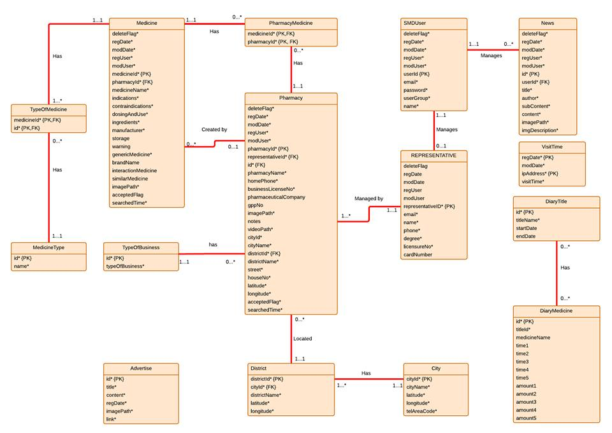

**Figure 4-2:** Entity relationship diagram

### Entity Detail

#### Medicine

|  |  |  |  |
| --- | --- | --- | --- |
| Attribute | Type | Mandatory | Description |
| Medicine ID | Number | PK, Y | The primary key auto generated by the system |
| Delete Flag | String | Y | Marked deleted |
| Register Date | Date | Y | Date register medicine |
| Modify Date | Date | Y | Date modify medicine |
| Register User | String | Y | User register medicine |
| Modify User | String | N | User modify medicine |
| Pharmacy ID | Number | Y (FK) | Number of pharmacy |
| Name | String | Y | Name of medicine |
| Indications | String | Y | Indication of medicine |
| Contraindications | String | Y | Contraindications of medicine |
| Dosing And Use | String | Y | Dosing and use of medicine |
| Ingredients | String | Y | Ingredients of medicine |
| Manufacturer | String | Y | Manufacturer of medicine |
| TypeOfPackageID | Number | Y | Type of package id of medicine |
| TypeOfPackageName | String | Y | Type of package name of medicine |
| Storage | String | N | Storage medicine |
| Warning | String | N | Warning of medicine |
| Generic Drug | String | N | Name generic of medicine |
| Brand Name | String | N | Brand name of medicine |
| Interaction Medicine | String | N | Interaction of medicine |
| Similar Medicine | String | N | Name of similar medicine |
| Image Path | String | Y | Path to image of medicine |
| Accepted Flag | String | N | Marked accepted |
| Search Time | String | N | Time to search |

#### Pharmacy

|  |  |  |  |
| --- | --- | --- | --- |
| Attribute | Type | Mandatory | Description |
| Pharmacy ID | Number | PK, Y | The primary key auto generated by the system |
| Delete Flag | String | Y | Marked deleted |
| Register Date | Date | Y | Date register medicine |
| Modify Date | Date | Y | Date modify medicine |
| Register User | String | Y | User register medicine |
| Modify User | String | N | User modify medicine |
| Name | String | Y | Name of pharmacy |
| Home Phone | Number | Y | Home phone number of pharmacy |
| Business License No | String | Y | Number business license of pharmacy |
| Pharmaceutical Company | String | N | Name of pharmaceutical company |
| Gpp No | String | N | Number of GPP |
| Notes | String | N | Notes about pharmacy |
| Money | String | N | Money of pharmacy |
| Image Path | String | Y | Path to image of pharmacy |
| Video Path | String | Y | Path to video of pharmacy |
| Representative ID | Number | Y | ID of representative |
| City | String | Y | City of pharmacy |
| District | String | Y | District of pharmacy |
| City ID | Number | Y | ID of city |
| District ID | Number | Y | ID of district |
| Street | String | Y | Street of pharmacy |
| House No | String | Y | Number house of pharmacy |
| Latitude | String | N | Latitude of pharmacy |
| Longitude | String | N | Longitude of pharmacy |
| Accepted Flag | String | N | Marked accepted |
| Searched Time | String | N | Time to search |
| TypeOfBusinessName | String | Y | Name of type business |

#### PharmacyMedicine

|  |  |  |  |
| --- | --- | --- | --- |
| Attribute | Type | Mandatory | Description |
| Pharmacy ID | Number | Y | ID of pharmacy |
| Medicine ID | Number | Y | ID of medicine |

#### SMD User

|  |  |  |  |
| --- | --- | --- | --- |
| Attribute | Type | Mandatory | Description |
| Delete Flag | String | Y | Marked deleted |
| Register Date | Date | Y | Date register medicine |
| Modify Date | Date | Y | Date modify medicine |
| Register User | String | Y | User register medicine |
| Modify User | String | N | User modify medicine |
| Email | String | Y | Email of User |
| Password | String | Y | Password of User |
| User Group | String | Y | Group of User |

#### Representative

|  |  |  |  |
| --- | --- | --- | --- |
| Attribute | Type | Mandatory | Description |
| Delete Flag | String | Y | Marked deleted |
| Register Date | Date | Y | Date register medicine |
| Modify Date | Date | Y | Date modify medicine |
| Register User | String | Y | User register medicine |
| Modify User | String | N | User modify medicine |
| Representative ID | Number | Y | Id of representative |
| Email | String | Y | Email of representative |
| Name | String | Y | Name of representative |
| Phone | Number | Y | Phone of representative |
| Degree | String | Y | Degree of representative |
| Licensure No | Number | Y | Licensure number of representative |
| Card Number | String | Y | Number card of representative |

#### Medicine Type

|  |  |  |  |
| --- | --- | --- | --- |
| Attribute | Type | Mandatory | Description |
| ID | Number | Y | Id of medicine type |
| Name | String | Y | Name of medicine type |

#### City

|  |  |  |  |
| --- | --- | --- | --- |
| Attribute | Type | Mandatory | Description |
| City ID | Number | Y | Id of City |
| City Name | String | Y | Name of city |
| Latitude | String | Y | Latitude of city |
| Longitude | String | Y | Longitude of city |
| Tel area code | String | y | Tel area code of city |

#### District

|  |  |  |  |
| --- | --- | --- | --- |
| Attribute | Type | Mandatory | Description |
| District ID | Number | Y | Id of District |
| District Name | String | Y | Name of District |
| Latitude | String | Y | Latitude of district |
| Longitude | String | Y | Longitude of district |
| City ID | Number | Y | ID of City |

#### News

|  |  |  |  |
| --- | --- | --- | --- |
| Attribute | Type | Mandatory | Description |
| Delete Flag | String | Y | Marked deleted |
| Register Date | Date | Y | Date register medicine |
| Modify Date | Date | Y | Date modify medicine |
| Register User | String | Y | User register medicine |
| Modify User | String | N | User modify medicine |
| News ID | Number | Y | Id of News |
| Title | String | Y | Title of News |
| Content | String | Y | Content of News |
| Image Path | String | Y | Path to image of News |
| Video Path | String | Y | Path to video of News |

#### Type Of Business

|  |  |  |  |
| --- | --- | --- | --- |
| Attribute | Type | Mandatory | Description |
| ID | Number | Y | ID of type |
| Type Of Business | String | Y | Type of business |

#### Visit Time

|  |  |  |  |
| --- | --- | --- | --- |
| Attribute | Type | Mandatory | Description |
| Register Date | Date | Y | Date register |
| Modify Date | Date | Y | Date modify |
| IP Address | String | Y | IP of address |
| Visit Time | String | Y | Time to visit |

#### Diary Title

|  |  |  |  |
| --- | --- | --- | --- |
| Attribute | Type | Mandatory | Description |
| ID | Number | Y | ID of diary |
| Title Name | String | Y | Name of title diary |
| Start Date | Date | N | Start Date of diary |
| End Date | Date | N | End Date of diary |

#### Diary Medicine

|  |  |  |  |
| --- | --- | --- | --- |
| Attribute | Type | Mandatory | Description |
| Medicine ID | Number | Y | ID of medicine |
| Title ID | Number | Y | ID of title |
| Time1 | String | N | Time use medicine |
| Time2 | String | N | Time use medicine |
| Time3 | String | N | Time use medicine |
| Time4 | String | N | Time use medicine |
| Time5 | String | N | Time use medicine |
| Amount1 | String | N | Amount medicine to use |
| Amount2 | String | N | Amount medicine to use |
| Amount3 | String | N | Amount medicine to use |
| Amount4 | String | N | Amount medicine to use |
| Amount5 | String | N | Amount medicine to use |